**CINEMATIC PROJECT PLANNING**

**CONTENTS**

Contents

[Overview 2](file:///C:\\Users\\35385\\Downloads\\GraphReport.docx" \l "_Toc40184624)

[Objectives or scope 2](file:///C:\Users\35385\Downloads\GraphReport.docx#_Toc40184625)

[General approach](file:///C:\\Users\\35385\\Downloads\\GraphReport.docx" \l "_Toc40184626)

[Contractual aspects](file:///C:\\Users\\35385\\Downloads\\GraphReport.docx" \l "_Toc40184626)

Project Planning6

Project Scheduling

[Resources, Equipment and Personnel](file:///C:\\Users\\35385\\Downloads\\GraphReport.docx" \l "_Toc40184624)

Cost analysis

[Risk management plans](file:///C:\\Users\\35385\\Downloads\\GraphReport.docx" \l "_Toc40184626)

[Evaluation methods](file:///C:\\Users\\35385\\Downloads\\GraphReport.docx" \l "_Toc40184626)

[Project Close](file:///C:\\Users\\35385\\Downloads\\GraphReport.docx" \l "_Toc40184626)

*[References](file:///C:\\Users\\35385\\Downloads\\GraphReport.docx" \l "_Toc40184626)*

1. **Overview**

The objective of this project is to provide an application platform for action movie-lovers/cinema goers to pick and choose what movie or genre they’d like to watch, know more about and purchase tickets. Each movie shown to the user will include a movie description, the genre and the duration as well as any other relevant information such as the actors in the movie and ratings. The app will also provide a comment section for each movie for anyone who wants to leave their opinions for others to view and respond to and have discussions with. The user will also have the option of buying tickets on the app and easily finding which cinemas are showing their desired movies and times.

On top of that, if the user has a favourite book they’d like to see on the big screen, they can take a photo of the book and upload it. The system will find a similar movie for the user, if it has been made into one, or a movie with a similar story-line to the book.

This application also provides interactivity and social aspects to enhance the user’s experience. The user has the option to be part of the movie. The system can offer multiple choice options during the movie, available on the users phone that can change the plot.

Lastly, to enhance the user’s experience even more with this application, the user can scan a QR code to connect to a VR headset. The user can select which movie landscape they wish to see through VR, via the application after scanning the QR code. if users go to the cinema they can use VR glasses provided by the cinema. The cinema can also provide an omni-directional treadmill if they wish to walk around in their selected movie landscape.

1. **Objectives or scope**

Using the Marketing Mix 5 Ps is a useful took that will help us create and chose the perfect marketing strategies for the deployment of this application [1]. The 5 areas we will be looking at to help us with the success of this deployment are:

* Product
* People
* Price
* Place
* Promotion

**Product:**

The product we are offering is the application called “Cinematic”. It will be available to download on Google play for use on the many Android devices that are available.

The branding for this application is crucial when marketing this application. The goals that will need to be fulfilled in terms of branding are as follows [2]:

* Ensuring that all involved stakeholders understand what the application is, what it’s used for, and the position of the team who brought “Cinematic” to the public.
* Increasing our significance in the market.
* Ensuring that our team has a good reputation, and all staff members are not involved in anything that will damage this reputation.

The branding of this application will include a slogan, “Where you can enjoy”. The aim of this slogan is to make the customer feel joyful when using the application. It will also include a logo which will consist of the name “Cinematic” in-front of a movie tape, something similar to the following:

With branding, brand warranty will be a point of discussion. This is the guarantee of the quality of the goods and service the application provides [5]. The warranty will provide customers a safety net for any legal issues. It is a claim that states that the service being offered to the customer is fit for its purpose.

**People:**

To ensure the success of this application, everyone from the staff such as the engineers to the stakeholders to the customers themselves need to be considered and thought of [3]. By reading statistics and articles about the film/VR industry in Ireland, we were able to deduce that it is constantly growing and people enjoy watching movies/TV shows on the go as well as in cinemas or in the comfort of their home. Knowing and caring for this need will attract and keep customers. Keeping tabs on customer satisfaction is essential to make sure that we are doing things right.

In terms of tending to the needs of staff, staff training will be provided if necessary. This will help make sure that no member of staff is left feeling under-qualified, overwhelmed or demotivated. Cinema staff will also be trained for the use of VR headsets and to ensure that everything runs safely and smoothly when customers come in to use them.

To cater to the needs of the stakeholders, consistent communication is essential so that no problems arise and anything that needs to be altered/removed from the application will be done in the early stages.

**Price:**

Costs such as advertising, the price of goods (tickets in this case) and paying the staff are all included in this section. This application will be selling tickets for movies. The tickets will be sold at either a child rate, adult rate or student rate – depending on what the rates are for the cinema the customer selects but also ensuring that a profit is made – finance will be contacted to discuss the rates. There will be offers around national holidays, including an end-of-school-year offer, that will entice more customers to use the app.

This application includes VR headset use. The headsets will be available at partner cinemas and will also be sold per person.

**Place:**

The application will need to deployed in the right time [5]. Place includes the distribution channels, in this case it’ll be online, as well as market coverage. In order to expand our application, we are planning to work with the cinemas, who will also be providing the VR headsets, to sell discounted tickets to customers who sign up to our application.

There will also be the option of making a desktop version of the application, where users can purchase tickets and access the QR code for the VR headset.

**Promotion:**

To promote this application, we will be advertising on social media platforms such as Instagram and Tiktok. We will make an account on both platforms and make posts that can reach our target audience. Our target audience consists of cinema-goers, movie-watchers as well as VR-fanatics.

Another way of advertising the application will be by asking our partner cinemas to advertise for us as a way of direct marketing - by putting up posters in the cinema to promote our application or advertise us, as well as asking customers if they’d like to sign up to our application when they buy tickets in the cinema.

**5. Project Planning**

The mind map above brainstorms the 5 Ps that are discussed in section 2, as well as the risk factors and the stakeholders involved in the application, which are also crucial to the success of the application. The references for this are all included in section 2 – objectives or scope.

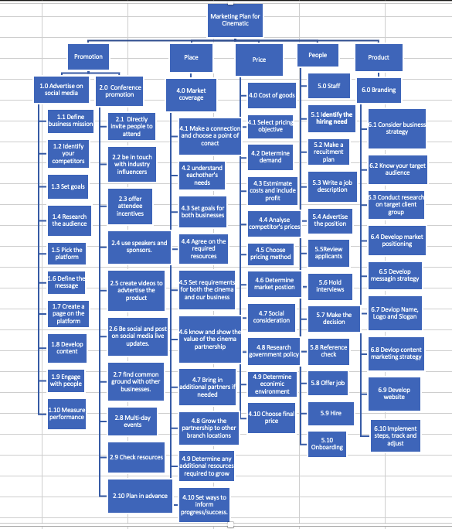

in the service structure above, I go through each of the steps for each of the 5 marketing Ps. References include [6], [7], [8], [9], [10], [11], [12], [13].

**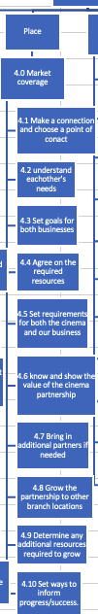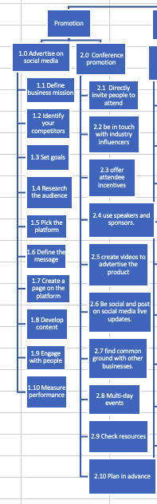**

**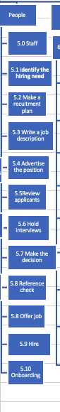**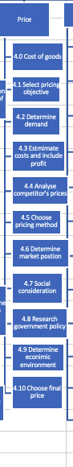

**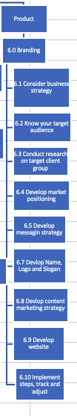**

**Action Plans**

|  |  |  |  |  |  |
| --- | --- | --- | --- | --- | --- |
| Action Plan 1 for WP 2: | | | | | |
| **Deliverables:**  Made a relationship with a cinema | | | | | |
| **Measures of Accomplishment / Milestones:**  Non-formal relationship made  First meeting | | | | | |
| **Key Constraints and Assumptions:**  Product ready to show to cinema  Product has gained a following and is advertised (WP2) | | | | | |
| Task No. | Tasks | Estimated Resources | Immediate Predecessor Tasks | Estimated Time Duration | Assigned to |
| 3.1 | Make a connection and choose a point of contact | Marketing assistant, cinema manager |  | 1 day | Marketing assistant 1 |
| 3.2 | Understand each other’s needs | Marketing assistant, R&D assistant | 3.1 | 4 hours | Marketing assistant 1, R&D assistant 1 |
| 3.3 | Set goals | Marketing assistant, R&D assistant | 3.2 | 1 hour | Marketing assistant 1, R&D assistant 1 |
| 3.4 | Agree on the required resources | Cinema manager, app manager | 3.3 | 1 hour | App manager |
| 3.5 | Set requirements for both the cinema and our business | Cinema manager, app manager | 3.4 | 1 hour | App manager |
| 3.6 | Show the value of this partnership | App manager, HR assistant | 3.5 | - | HR assistant |
| 3.7 | Bring in additional partners if needed | Marketing assistant | 3.6 | - | Marketing assistant 1 |
| 3.8 | Grow the partnership to other branch locations | Marketing assistant, cinema manager | 3.7 | - | Marketing assistant 1 |
| 3.9 | Determine if additional resources are needed to grow | Marketing assistant, R&D assistant | 3.8 | 1 hour | Marketing assistant 1, R&D assistant |
| 3.10 | Set ways to inform progress/success | Cinema manager , app manager, HR assistant | 3.9 | 1 hour | HR assistant |
|  |  |  |  |  |  |
|  |  |  |  |  |  |

|  |  |  |  |  |  |
| --- | --- | --- | --- | --- | --- |
| Action Plan 2 for WP 1: Advertising on Social Media | | | | | |
| **Deliverables:**  Advertised on social media | | | | | |
| **Measures of Accomplishment / Milestones:**  Posting first content  Using advertisement tools | | | | | |
| **Key Constraints and Assumptions:**  Product ready to show and filmed  Branding of the product is completed (WP6) | | | | | |
| Task No. | Tasks | Estimated Resources | Immediate Predecessor Tasks | Estimated Time Duration | Assigned to |
| 1.0 | Advertise on social media | - |  |  |  |
| 1.1 | Define business mission | Marketing assistant | - | 2 hours | Marketing team |
| 1.2 | Identify competitors | Marketing assistant, R&D assistant | 1.1 | 3 hours | Marketing team |
| 1.3 | Set goals | Market assistant | 1.2 | 2 hours | Marketing team |
| 1.4 | Research the audience | R&D assistant | 1.3 | 1 day | Researcher 1 |
| 1.5 | Pick the platform | Social media officer, phone | 1.4 | 30 mins | Social media officer 1 |
| 1.6 | Define the message | Marketing assistant | 1.5 | 2 hours | Marketing team |
| 1.7 | Create a page on the chosen platform | Social media officer, phone | 1.6 | 15 mins | Social media officer 1 |
| 1.8 | Develop content | Marketing assistant, phone, camera | 1.7 | - | Marketing assistant 1 |
| 1.9 | Engage with people | Marketing assistant, phone | 1.8 | - | Marketing assistant 1 |
| 1.10 | Measure performance | Marketing assistant , | 1.9 | - | Marketing assistant 1 |
|  |  |  |  |  |  |

|  |  |  |  |  |  |
| --- | --- | --- | --- | --- | --- |
| Action Plan 3 for WP 6 : Branding | | | | | |
| **Deliverables:**  Branding of product is complete | | | | | |
| **Measures of Accomplishment / Milestones:**  Name, logo and slogan is chosen  Website is developed | | | | | |
| **Key Constraints and Assumptions:**  Application is developed | | | | | |
| Task No. | Tasks | Estimated Resources | Immediate Predecessor Tasks | Estimated Time Duration | Assigned to |
| 6.1 | Consider business strategy | Marketing assistant |  | 1 hour | Marketing assistant 1 |
| 6.2 | Know target audience | Marketing assistant | 6.1 | 2 hours | Marketing assistant 1 |
| 6.3 | Conduct research on target client group | R&D assistant | 6.2 | 3 days | R&D assistant 1 |
| 6.4 | Develop marketing positioning | Marketing assistant | 6.3 | 2 days | Marketing assistant 1 |
| 6.5 | Develop messaging strategy | Marketing assistant | 6.4 | 3 hours | Marketing assistant 1 |
| 6.6 | Develop name, logo and slogan | Marketing assistant | 6.5 | 5 days | Marketing team |
| 6.7 | Develop content marketing strategy | Marketing assistant | 6.6 | 3 days | Marketing assistant 1 |
| 6.8 | Develop website | Software engineers | 6.7 | 1 month | Software engineers |
| 6.9 | Implement steps, keep track, and adjust | Marketing assistant | 6.8 | - | Marketing team |
|  |  |  |  |  |  |
|  |  |  |  |  |  |

|  |  |  |  |  |  |
| --- | --- | --- | --- | --- | --- |
| Action Plan 4 for WP 5: Hiring staff | | | | | |
| **Deliverables:**  Staff are hired | | | | | |
| **Measures of Accomplishment / Milestones:**  Full staff hired | | | | | |
| **Key Constraints and Assumptions:**  HR team to hire staff | | | | | |
| Task No. | Tasks | Estimated Resources | Immediate Predecessor Tasks | Estimated Time Duration | Assigned to |
| 5.1 | Identify the hiring need | App manager | - | 2 hours | App manager |
| 5.2 | Make a recruitment plan | HR assistant | 5.1 | 3 hours | HR assistant 1 |
| 5.3 | Write a job description | HR assistant, app manager | 5.2 | 2 hours | HR assistant 1, app manager |
| 5.4 | Advertise the position | HR assistant | 5.3 | 4 hours | HR assistant 1 |
| 5.5 | Review applicants | HR assistant | 5.4 | 3 days | HR assistant 1 |
| 5.6 | Hold interviews | HR assistant, app manager | 5.5 | 5 days | HR assistant 1, app manager |
| 5.7 | Make the decision | App manager | 5.6 | 1 day | App manager |
| 5.8 | Reference check | HR assistant | 5.7 | 1 day | HR assistant 1 |
| 5.9 | Offer job | HR assistant | 5.8 | 1 hour | HR assistant 1 |
| 5.10 | Hire | HR assistant | 5.9 | - | HR assistant 1 |
|  |  |  |  |  |  |

|  |  |  |  |  |  |
| --- | --- | --- | --- | --- | --- |
| Action Plan 5 for WP 1: cost of goods | | | | | |
| **Deliverables:**  Determined cost of goods | | | | | |
| **Measures of Accomplishment / Milestones:**  Final price chosen | | | | | |
| **Key Constraints and Assumptions:**  Product ready to sell | | | | | |
| Task No. | Tasks | Estimated Resources | Immediate Predecessor Tasks | Estimated Time Duration | Assigned to |
| 4.1 | Select pricing objective | Finance assistant | - | 3 hours | Finance assistant 1 |
| 4.2 | Determine demand | Finance assistant, R&D assistant | 4.1 | 2 hours | Finance assistant 1 |
| 4.3 | Estimate costs and include profit | Finance assistant | 4.2 | 6 hours | Finance assistant 1 |
| 4.4 | Analyse competitor’s prices | Finance assistant | 4.3 | 3 hours | Finance assistant 1 |
| 4.5 | Choose pricing method | Finance assistant | 4.4 | 4 hours | Finance assistant 1 |
| 4.6 | Determine market position | Finance assistant, marketing assistant | 4.5 | 5 hours | Marketing assistant 1 |
| 4.7 | Social consideration | R&D assistant | 4.6 | 3 hours | R&D assistant 1 |
| 4.8 | Research government policy | R&D assistant | 4.7 | 6 hours | R&D assistant 1 |
| 4.9 | Determine economic environment | Finance assistant | 4.8 | 3 hours | Finance assistant 1 |
| 4.10 | Choose final price | Finance assistant, app manager | 4.9 | 1 day | App manager |
|  |  |  |  |  |  |

**Project Scheduling**

**Entry tables**

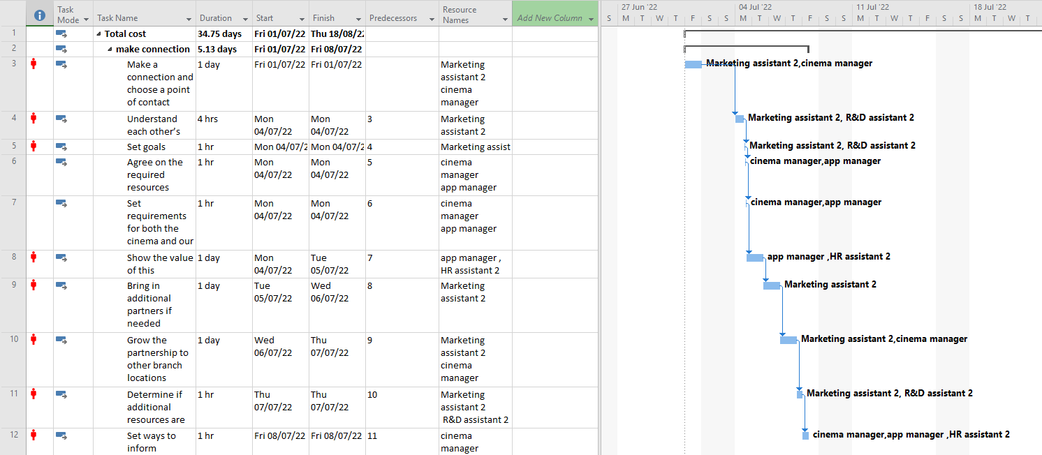

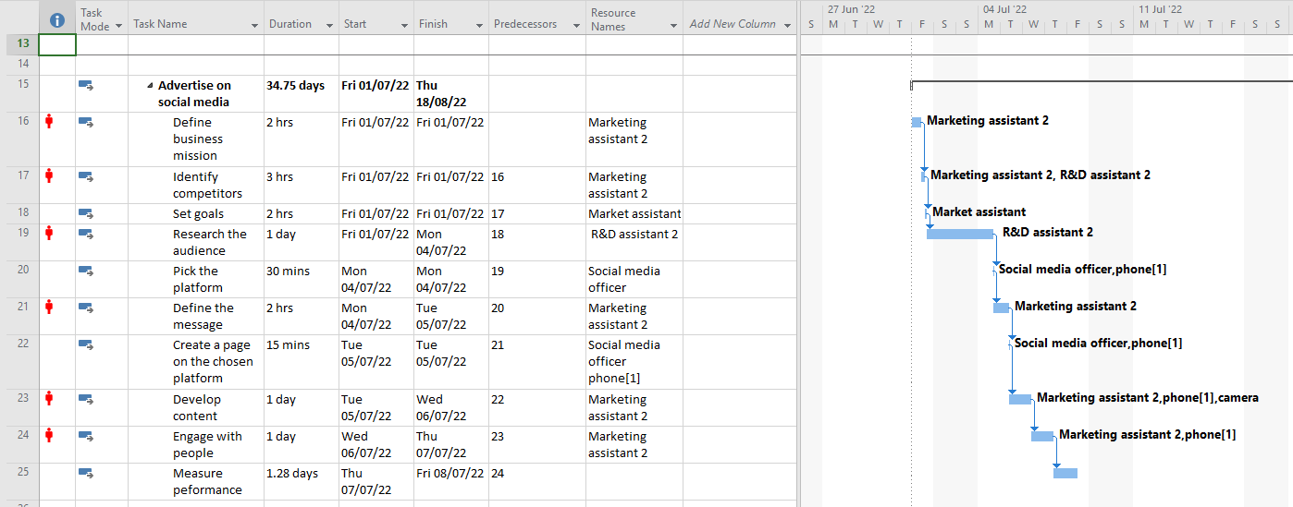

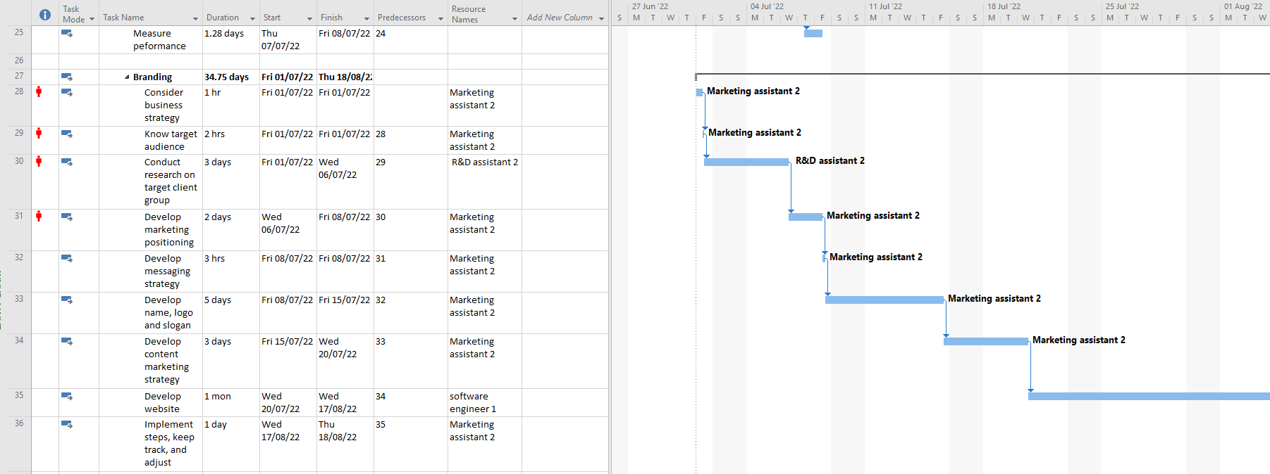

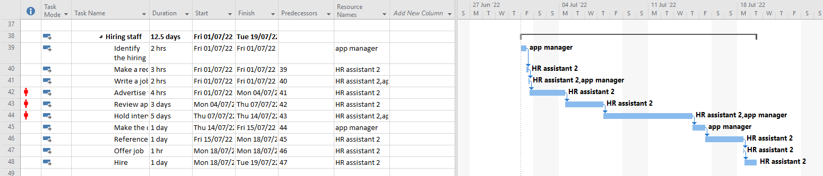

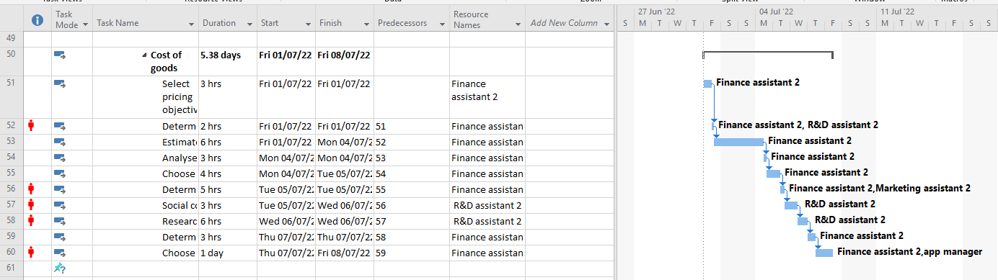some employees/resources are seen in more than one table as they are either attending meetings or providing some help.

**Cost tables**

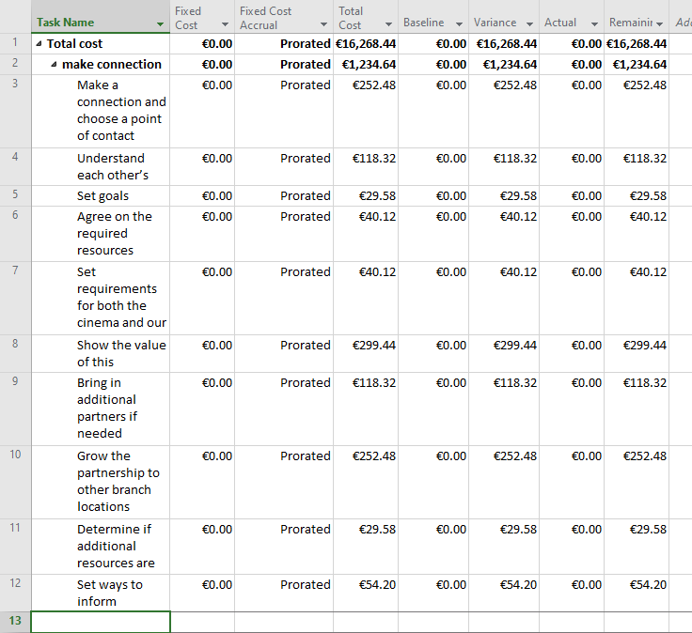

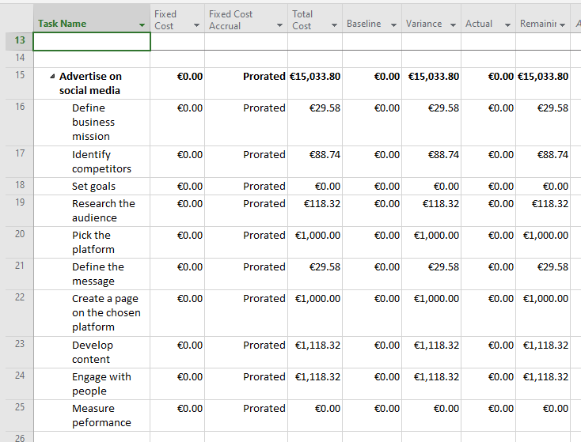

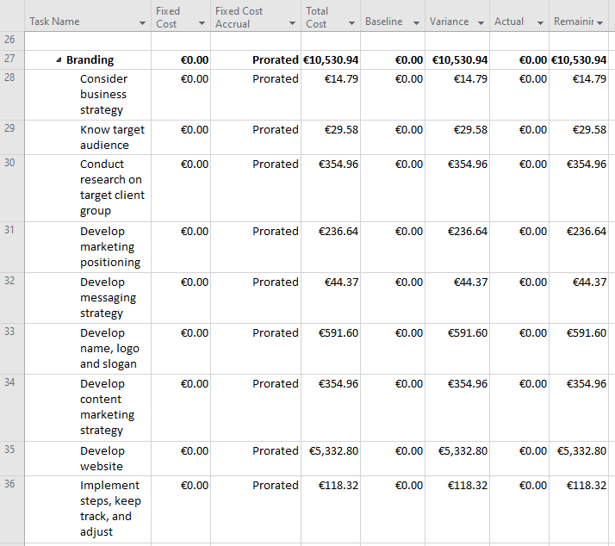

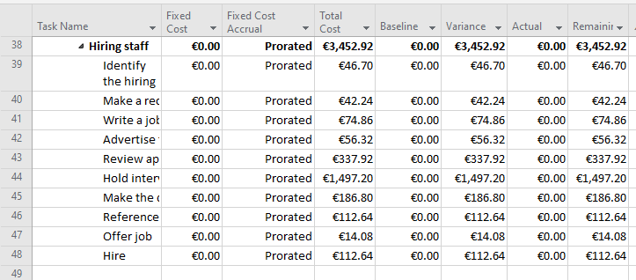

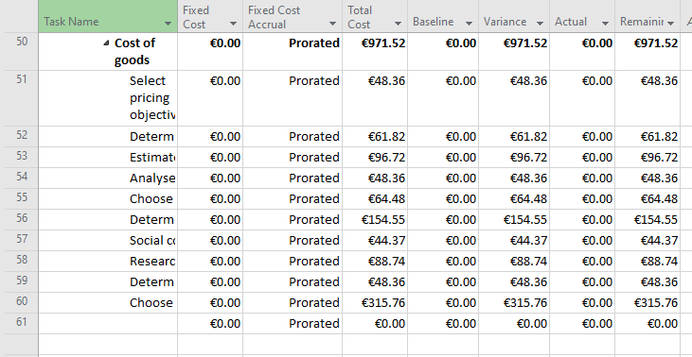

**12. References**

# [1] “ THE MARKETING MIX 5 PS- HELPING YOU CHOOSE THE RIGHT STRATEGIES”,

<https://inhousemarketing.co.nz/the-marketing-mix-5-ps-helping-you-choose-the-right-strategies/> , 19/11/2022

# [2]” What is Branding and How to Manage Your Brand’s Image”, 26/01 , Rock Content Writer, <https://rockcontent.com/blog/branding/> , 19/11/2022

# [3] “Discover the Value the 5 P’s of Marketing Can Bring”, 09/12/21, Rock Content Writer, <https://rockcontent.com/blog/5-ps-of-marketing/> , 20/11/2022

[4] “ THE MARKETING MIX 5 PS- HELPING YOU CHOOSE THE RIGHT STRATEGIES”, <https://inhousemarketing.co.nz/the-marketing-mix-5-ps-helping-you-choose-the-right-strategies/> , 20/11/2022

[5] “Warranty”, 04/2016, TechTarget Contributor, <https://www.techtarget.com/whatis/definition/warranty> , 20/11/2022

[6] “A 10 step Brand Development Strategy for Your Professional Services Firm”, Lee Frederiksen, <https://hingemarketing.com/blog/story/a_10_step_brand_development_strategy_for_your_professional_services_firm> , 30/11/2022

[7] “5 Tips For Marketing Your Business At Conferences” , 03/03/2016 , Alex Ivanovs, <https://www.hostgator.com/blog/business-marketing-at-conferences/> , 30/11/2022

[8] “9 innovative, brand building conference ideas (that sell registrations!)”, thinkbusinessevents, <https://thinkbusinessevents.com.au/portfolio-items/conference-marketing-ideas/> **,** 30/11/2022

[9] “10 Steps to Form and Sustain a Partnership ”, Skilled Trades Playbook, <https://www.skilledtradesplaybook.org/10-steps-form-sustain-partnership/> , 30/11/2022

[10] ”Hiring Process Steps”, SmartRecruiters, <https://www.smartrecruiters.com/resources/glossary/hiring-process-steps/> , 30/11/2022

[11] “ 10 Steps to the Perfect Social Media Marketing Strategy for Your Business [Infographic]”, 31/05/2022, Mark Walker-Ford, <https://www.socialmediatoday.com/news/10-steps-to-the-perfect-social-media-marketing-strategy-for-your-business/624584/> , 30/11/2022

[12] “What are the 6 Steps in Determining Price ”, 29/10/2022, Gareth Parkin, <https://www.gopromotional.co.uk/blog/what-are-the-6-steps-in-determining-price/> , 30/11/2022

[13] “ Pricing of Products: 12 Factors | Economics”, Sandhya S, <https://www.economicsdiscussion.net/pricing/pricing-of-products-12-factors-economics/29550> , 30/11/2022